|  |  |  |  |  |
| --- | --- | --- | --- | --- |
| **National University of Computer and Emerging Sciences, Lahore Campus** | | | | |
| C:\Users\saif\AppData\Local\Microsoft\Windows\Temporary Internet Files\Content.Word\final design.jpg | **Course Name:** | **Computer Networks Lab** | **Course Code:** | **Cl-307** |
| **Program:** | **BS (Computer Science)** | **Semester:** | **Spring 2017** |
| **Duration:** | **180 Minutes** | **Total Marks:** | **35** |
| **Paper Date:** | **12-December-2018** | **Weight** | **30%** |
| **Section:** | **ALL** | **Page(s):** | **4** |
| **Exam Type:** | **Final** |  |  |
| **Student : Name:_____________________________ Roll No.________________ Section:_______** | | | | |
| **Instruction/Notes:** | **READ ALL INSTRUCTIONS CAREFULLY.**  1. Understanding the question paper is also part of the exam, so do not ask any clarification. Make suitable ASSUMPTIONS.  2**.** Final Submissionsshould be done in your respective section folder on \\**sandata\xeon\Fall 2018\COMPUTER NETWORKS LAB\Final Submissions**. Each question related files must be in **separate folder (Question 1, Question 2)** and all the separate folders must be in a single zip file. **Zip file must be renamed after your roll number e.g., “14L-4125”. Multiple submissions are not allowed** **(if done, only first one will be considered)**  3. You are immediately disqualified from the exam if:  i. You are seen talking, whispering, borrowing or looking at someone’s PC  ii. A USB is found attached to your PC  iii. You are caught accessing internet. | | | |

**Part 1 Network Simulator 2 (Marks: 15)**

**\*\*Submission: You have to submit your (Roll-No.tcl) file in a folder named Question 1. You should provide screen shots of your working code along with the tcl file \*\***

You will have to create a hybrid topolgy as given in the diagram below using statements in correct format from ns2 to implement the Distance vector routing protocol. Assume all the devices in the topology as nodes and all the wires as duplex links having a capacity of 1.5Mb and a propagation delay of 10ms with a stochastic fair queue scheduling algorithm. You must orient the nodes as shown in the topology below. You will have to send TCP data from p3 to p9 and from p5 to p12. You will have to send UDP data with a rate of 2200 packets/44 seconds with a single packet having a size of 1.5 Kilo Bytes from p13 to p6. Also send udp traffic from p1 to p8 such that 14800 packets are generated after each 37 seconds with each packet having a size of 5.5 Kilo Bytes.

**Note: Implement the task using less number of statements to get the full marks.**

**Scheduling Events:**

* TCP Data: From p3 to p9 (Start: 0.2, Stop: 1.8), From p5 to p12 (Start: 0.3, Stop: 1.4)
* UDP Data: From p13 to p6 (Start: 0.4, Stop:1.6), From p1 to p8 (Start: 0.7, Stop:1.7)
* Bring the link between r1 and r2 down at 0.7 and bring it back up at 1.0
* Bring the link between r4 and r3 down at 0.9 and bring it back up at 1.3
* 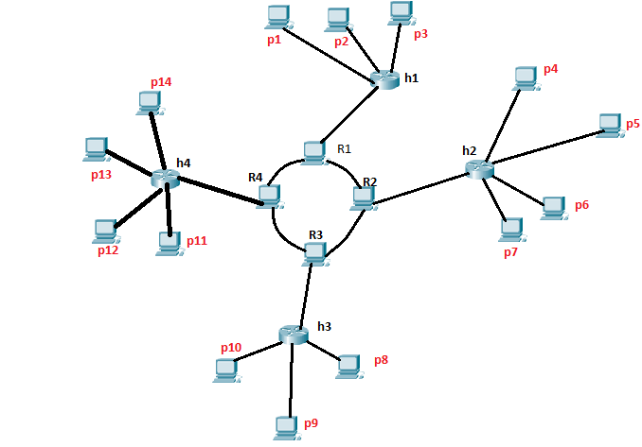Stop the simulation at 2.0

**NS2 Syntax:**

**Create Simulation:** set ns [new Simulator]

**Trace Files for NAM**: set nf [open out.nam w]

$ns namtrace-all $nf

**Finish Procedure:** proc finish {} {

global ns nf

$ns flush-trace

close $nf

exec nam out.nam &

exit 0

}

**Routing Algorithm**: $ns rtproto <protocol_name>; <protocol_name>: DV

**Node creation**: set <node_name> [$ns node]

**Links Creation**: $ns <link_type> <node1> <node2> <Bandwidth> <Delay> <queue_type>

<link_type>: simplex-link, duplex-link; <queue_type>: DropTail, SFQ

**Graphical Settings (NAM)**: $ns <type> <node1> <node2> <option> <args>

<type> : simplex-link-op, duplex-link-op; <option> : orient, queuePos

**Limiting Queue**: $ns queue-limit <node_name> <node_name> <no. of packets>

**Transport Layer**: set <layer_name> [new Agent/<agent_type>]

<agent_type>: UDP,TCP,Null,TCPSink

**Attaching Transport layer:** $ns attach-agent <node_name> <layer_name>

**Connecting Transport layer:** $ns connect <layer_name> <layer_name>

**File Transfer Protocol:** set <ftp_name> [new Application/FTP]

**FTP Attach Agent:** <ftp_name> attach-agent <layer_name>

**Constant Bit Rate:** set <cbr_name> [new Application/Traffic/CBR]

**CBR Attach Agent:** <cbr_name> attach-agent <layer_name>

**CBR Parameters:** <cbr_name>set <parameter> <parameter_value>

<parameter>: packetSize_, interval_, rate_

**Event Scheduling:** $ns at <time_frame_value> “<cbr_name>/<ftp_name> <time_event>”

<time_event>: start, stop

**Ending Simulation:** $ns at <time_frame_value> “finish”

**Run Simulation:** $ns run

**Link Up/Down:** $ns rtmodel-at <time_frame_value> <function> <node1> <node2>

<function>: up,down

_____________________________________________________________________________

**Part 2 CISCO PACKET TRACER (Marks: 20)**

**\*\*Submission: You have to submit your (Roll-No.pkt) file along with the screen shots of the CLI Code (Only for the configuration of RIPv2) of all the routers in a folder named Question 2 \*\***

Suppose that you are the CEO of a startup which deals with network configuration for various companies. After 100 days of struggle, you have finally received your first assignment to configure the network for three different companies in such a way that all the PCs in each company must be able to communicate with each other as well as with all the PCs of any other company.

The companies are named as **CMP X**, **CMP Y** and **CMP Z**. **CMP X** has got **5 Rooms** with **1 PC** in each room, **CMP Y** has got **3 Rooms** with **3 PCs** in each room and **CMP Z** has got **2 Rooms** having **4 PCs** in each room. The IP regulating company has assigned following IP network addresses to each of the company:

**CMP X: 144.186.96.0/19** **CMP Y: 50.152.0.0/15** **CMP Z: 210.98.169.64/26**

As the part of the agreement, all three companies have asked you to bear the expense of all the switches and routers used to interconnect all the computers in a merged network for three companies and further instructed you that all the PCs in single room must be on same sub network and all the rooms of a single company must be on a different sub-network which will be assigned after sub-netting the assigned **network address** only for the relevant company (no outside network or the network of other company will be accepted) e.g., each room for CMP X will be assigned a different subnetwork after sub netting the address of 144.186.96.0/19 only and not any other network address. The companies have further informed you that companies plan to extend the number of their PCs in each room in the future.

You, being, cleverly economical decide to install old switches (**Generic Switches** in Cisco Packet Tracer) with only **three Ethernet ports working out of four** and routers (**Generic Routers** in Cisco Packet Tracer) to configure the network for three companies in such a way that you use as much less routers and switches as possible. You have also bought the following IP network address for the serial communication between different routers which will be connecting different Inter-Company and Intra-Company subnets. You plan to form the subnets of the following address in order to cater the serial communication between all the routers:

**Routers Serial Communication: 199.210.121.160/28**

You, being very cautious, decide to simulate the topology on Cisco Packet Tracer in order to optimally design the network considering the number of devices (switches, routers etc.) used to maximize the profit margins of your company. However, you must simulate the topology strictly following rules and regulations described below:

1. Use Straight Through wires, Cross Over cables or Serial DCE wires where necessary and applicable
2. Use **Generic** Router and **Generic** PCs for your design
3. Use **Generic Switches** such that you attach **only 3 of the 4** available **Ethernet interfaces** for a single switch, however, you can attach as many switches considering optimal design
4. You have to assign IPs to the PCs using **Static IP allocation**
5. Although you have to use GUI of the router to configure its interfaces but you must use CLI of the router to configure the **RIPv2 protocol** for **Classless Subnet addressing** and attach screen shots of the CLI code (You can use snipping tool to take screen shots or you can attach a text file having the CLI code of each router).

**Clearly mention each subnet address using comments and make your design as neat as possible to get the full credit**